Car tutorial
You can use any car you want but make sure is has different wheel meshes.
I got the car from here https://youtu.be/DU-yminXEX0?si=Oitqs3o-FuvxQnyK
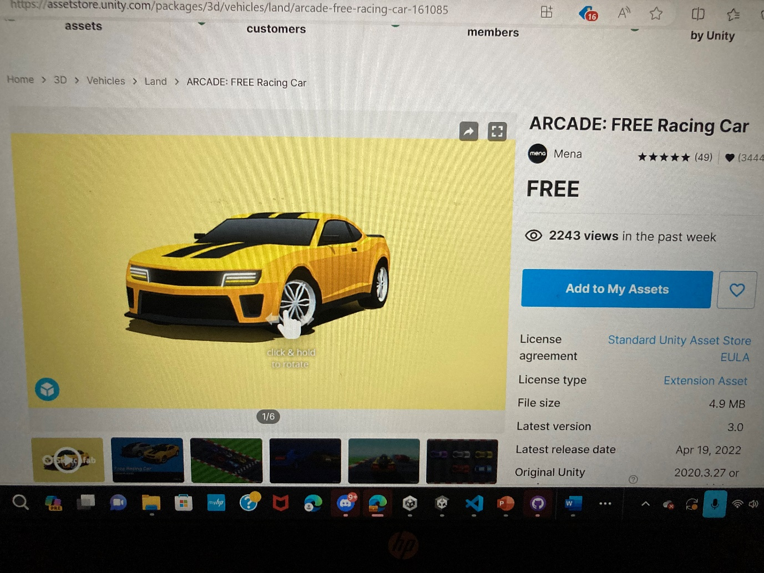
Move white thing to add to my assets then press left mouse.
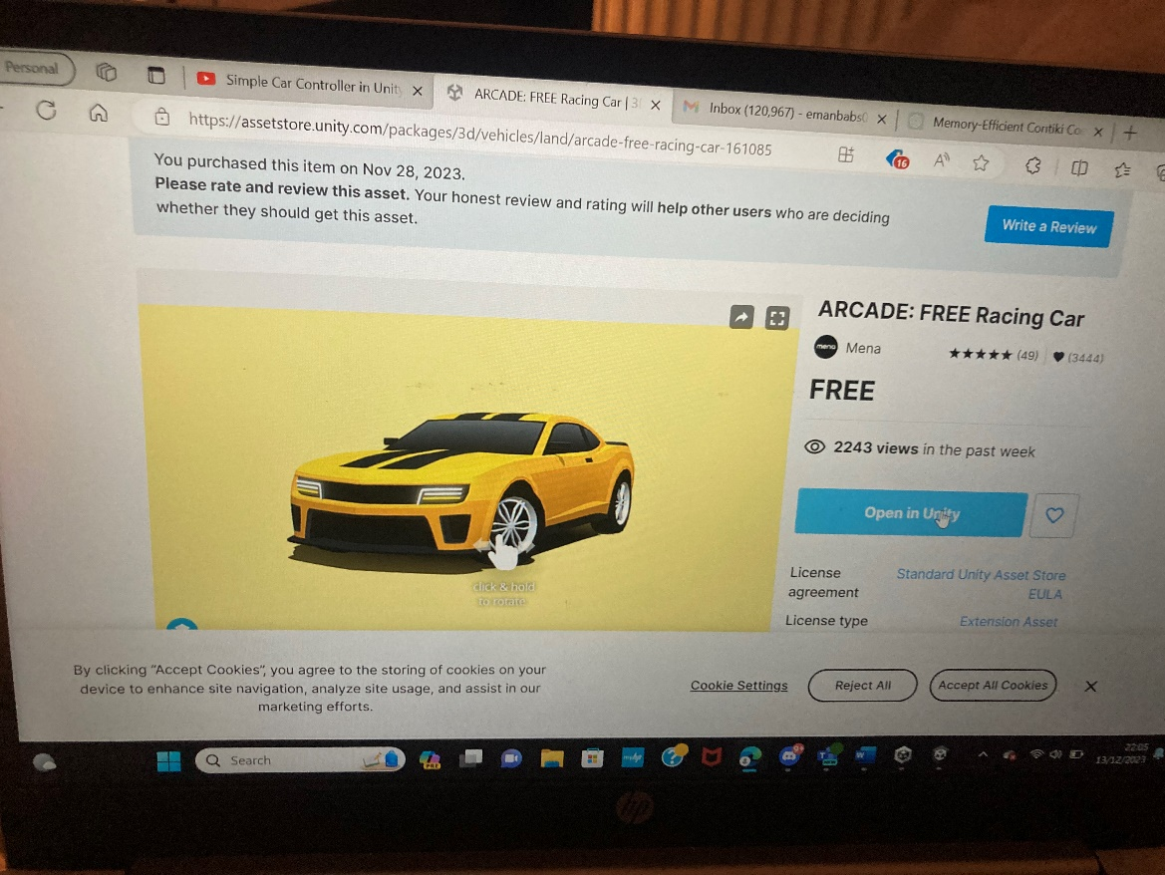
Move mouse on open in unity and press on left mouse twice quickly.
When you press import on cars go to all prefabs and press car and drag it to sample scene.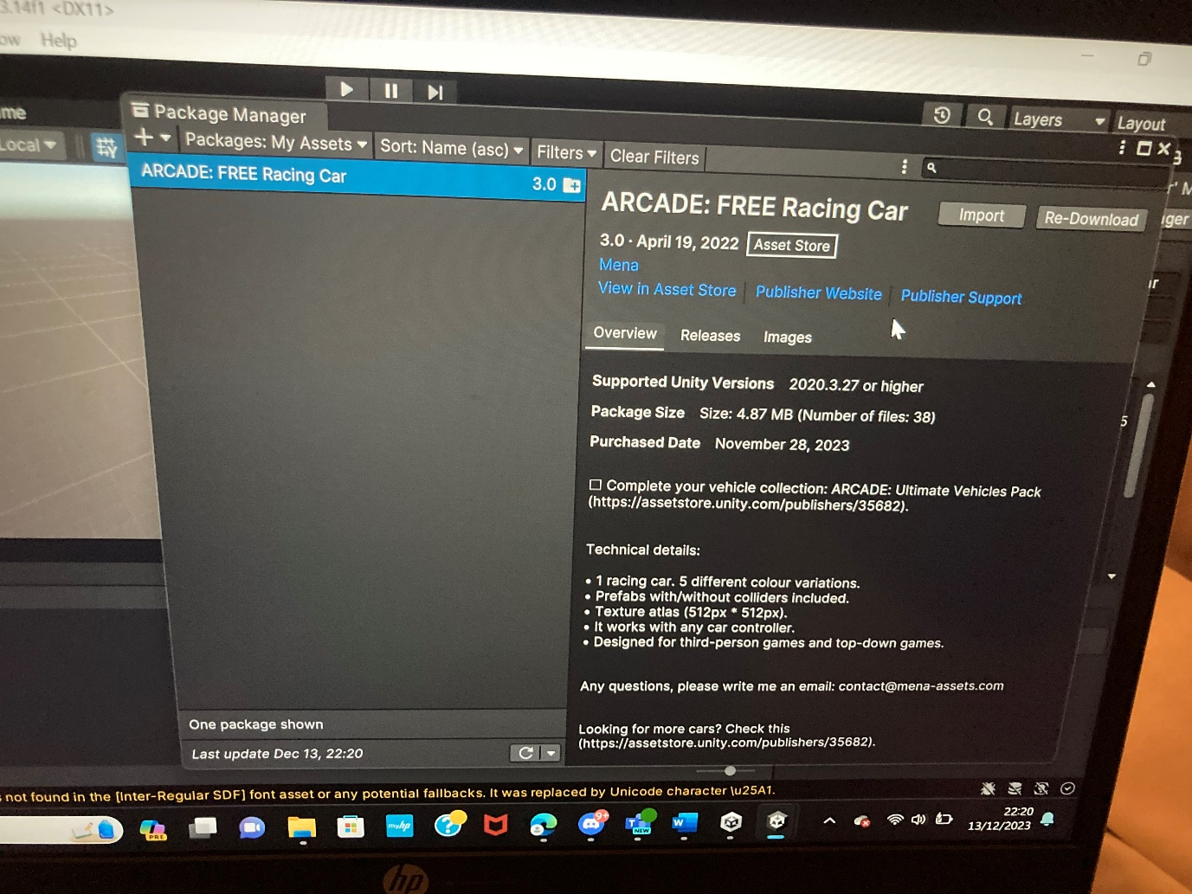
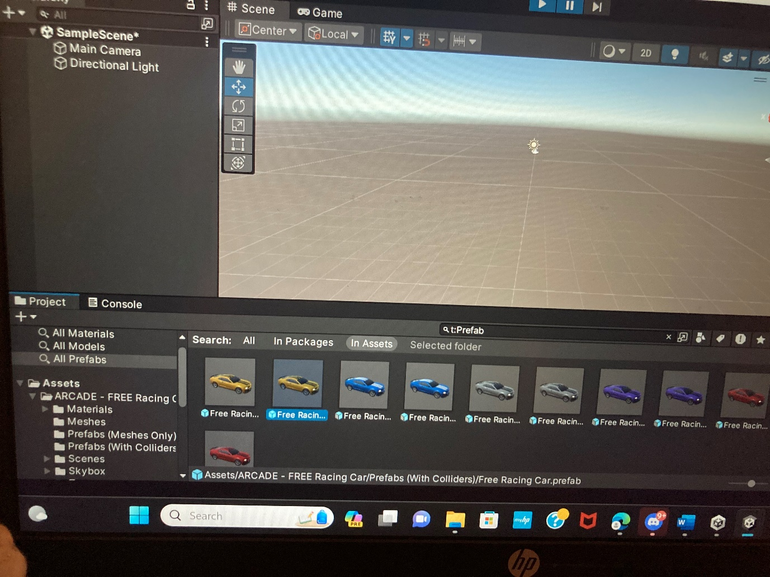

Put plane in sample scene too so the car has something to stand on and doesn’t fall down.
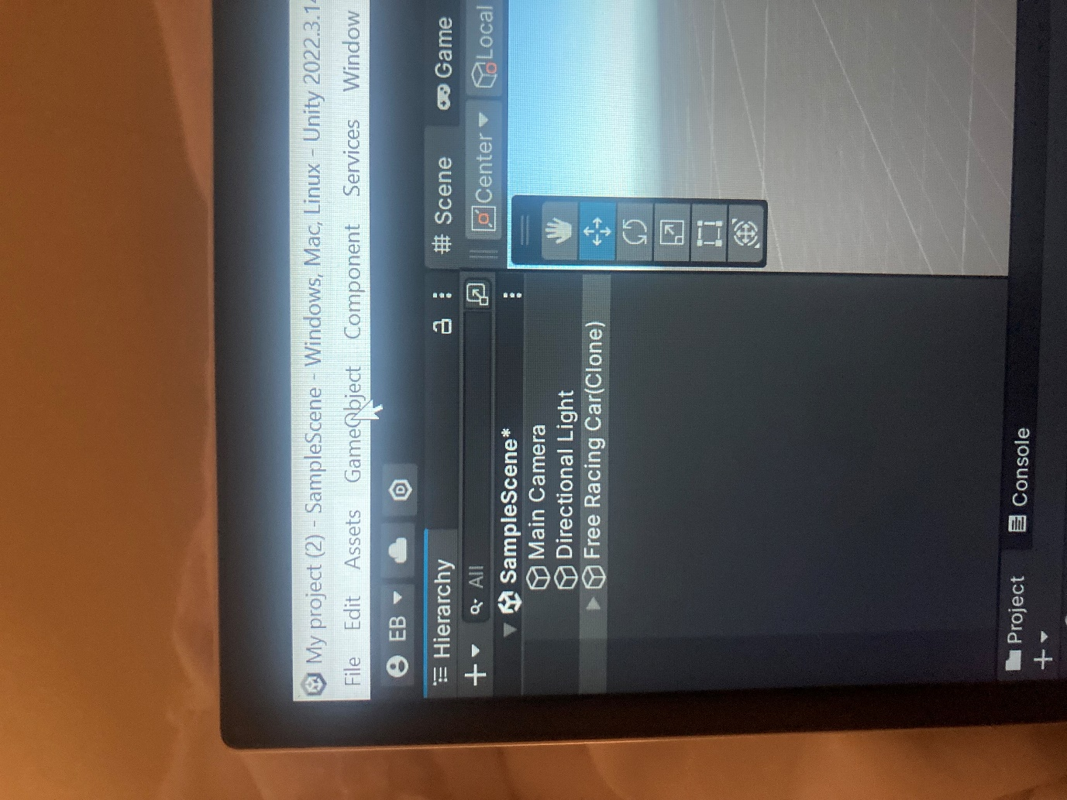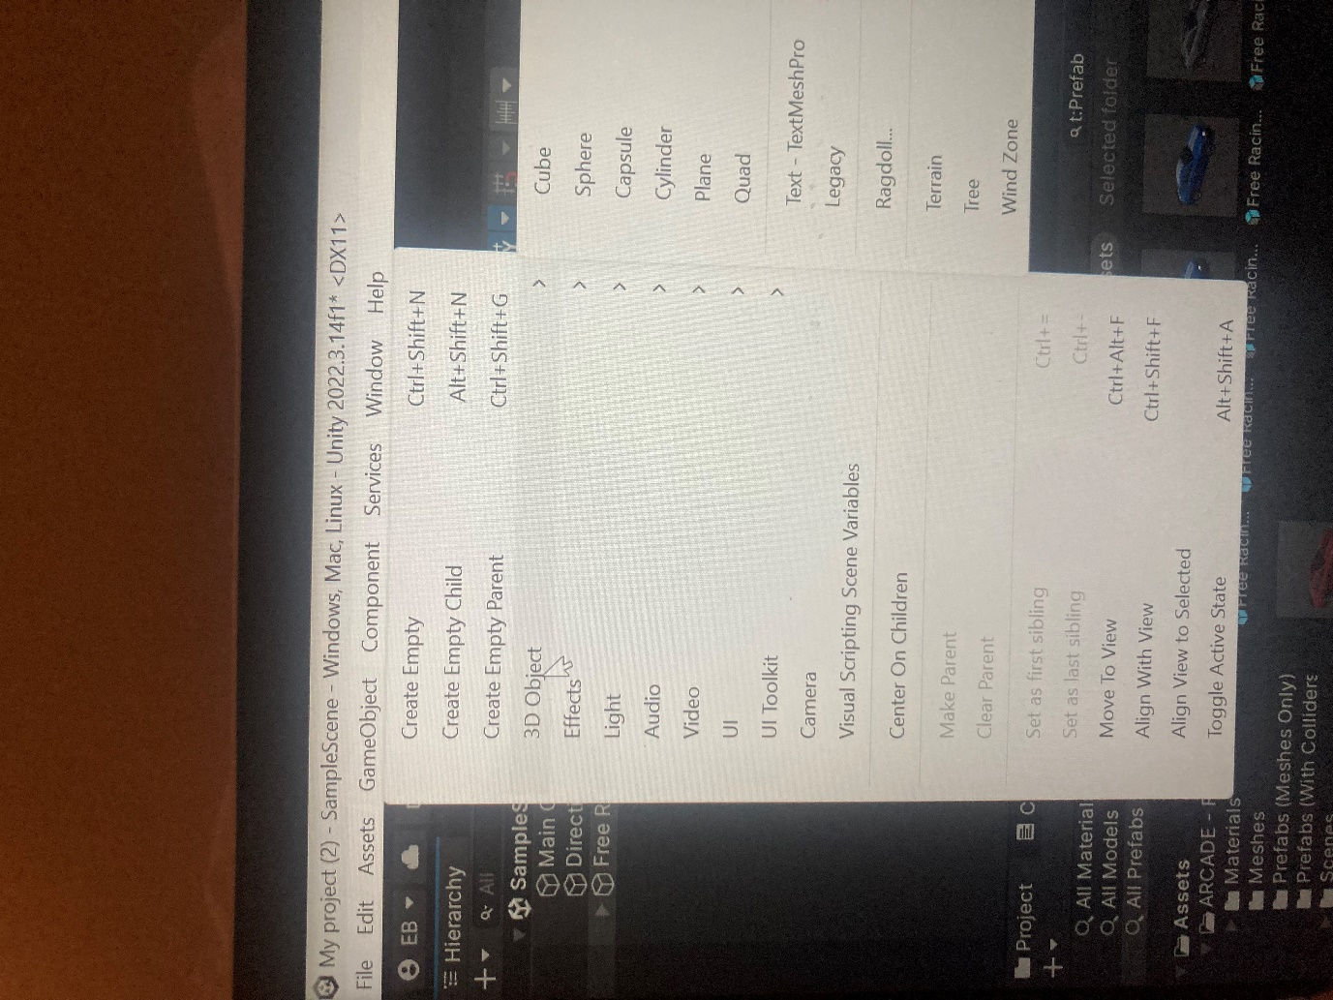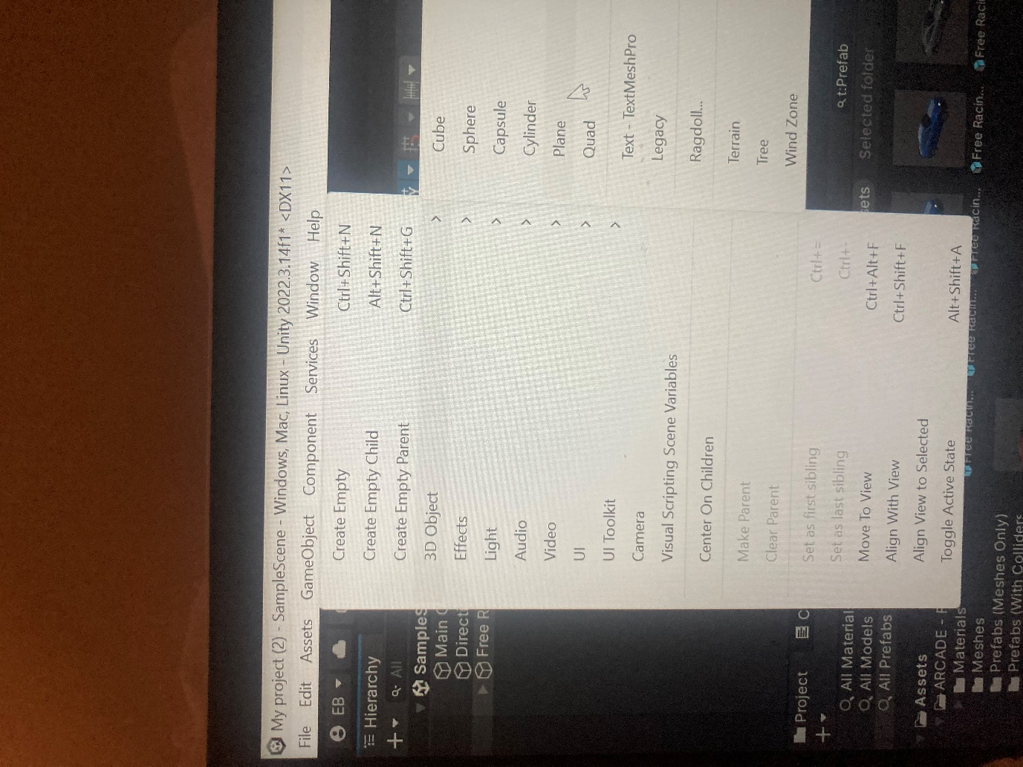
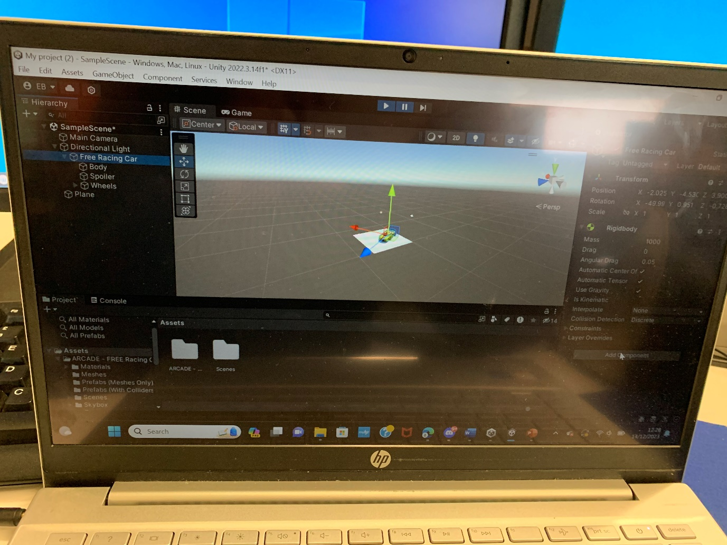
We’re first going to add box collider to root object and we do this by pressing on car then add component.
Press physics 2D
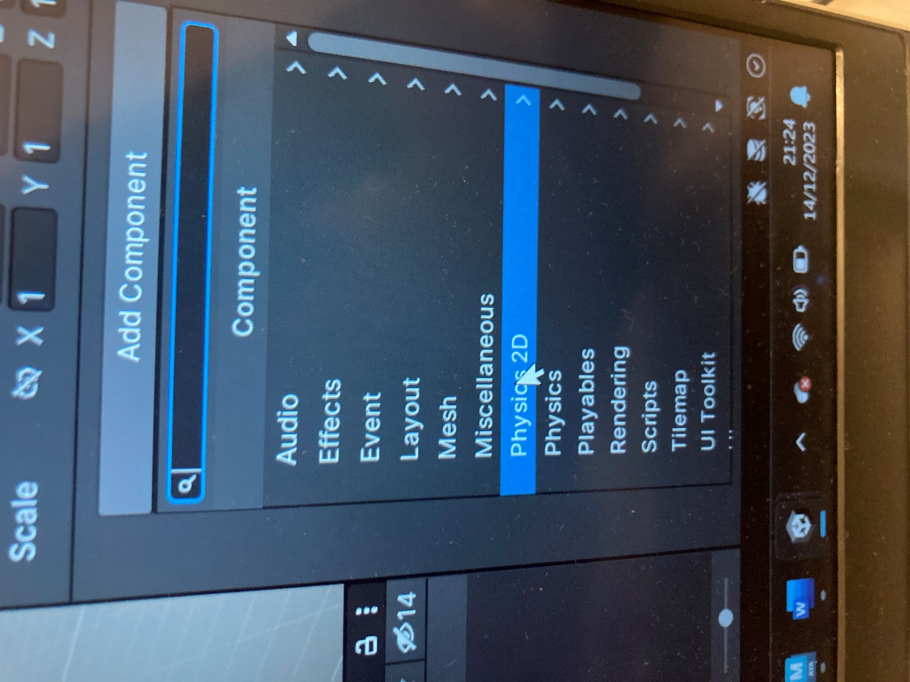

Then press box collider 2D
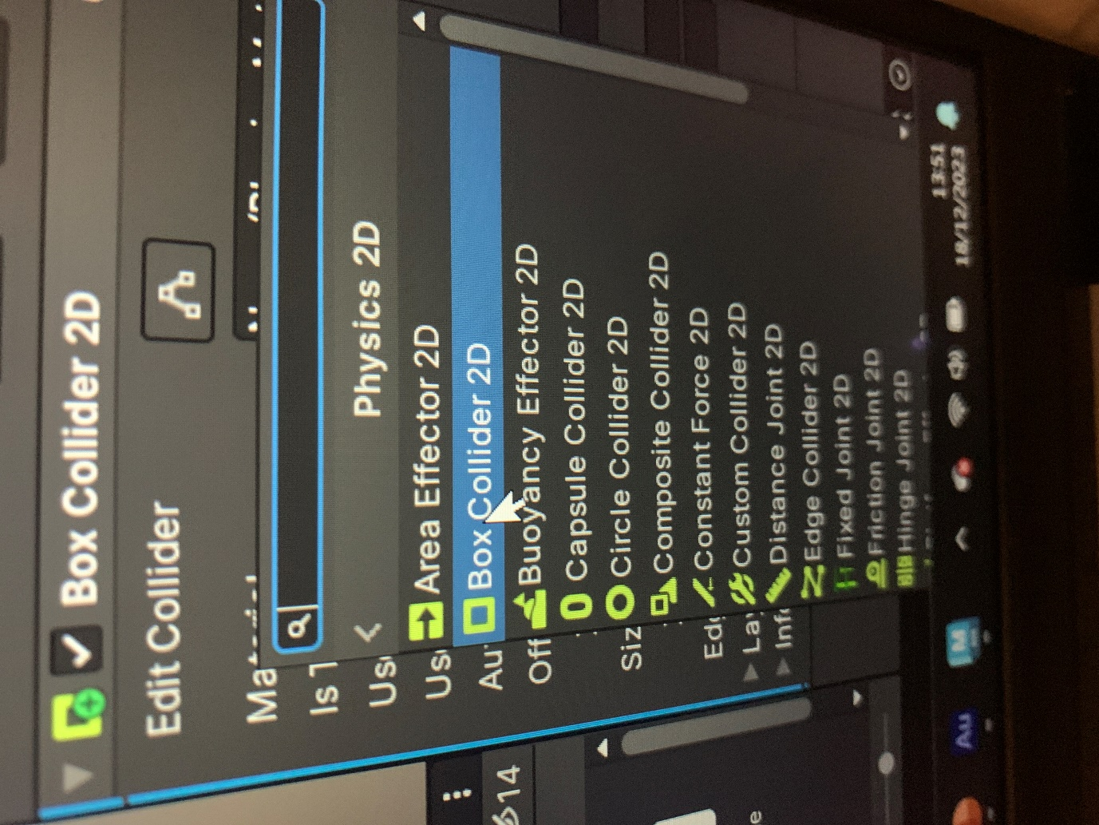

Change the collider so that it fits the car. You can go in front and side view when doing this. Make sure collider doesn’t touch the ground because the wheels will need to do this and otherwise the car controller won’t work
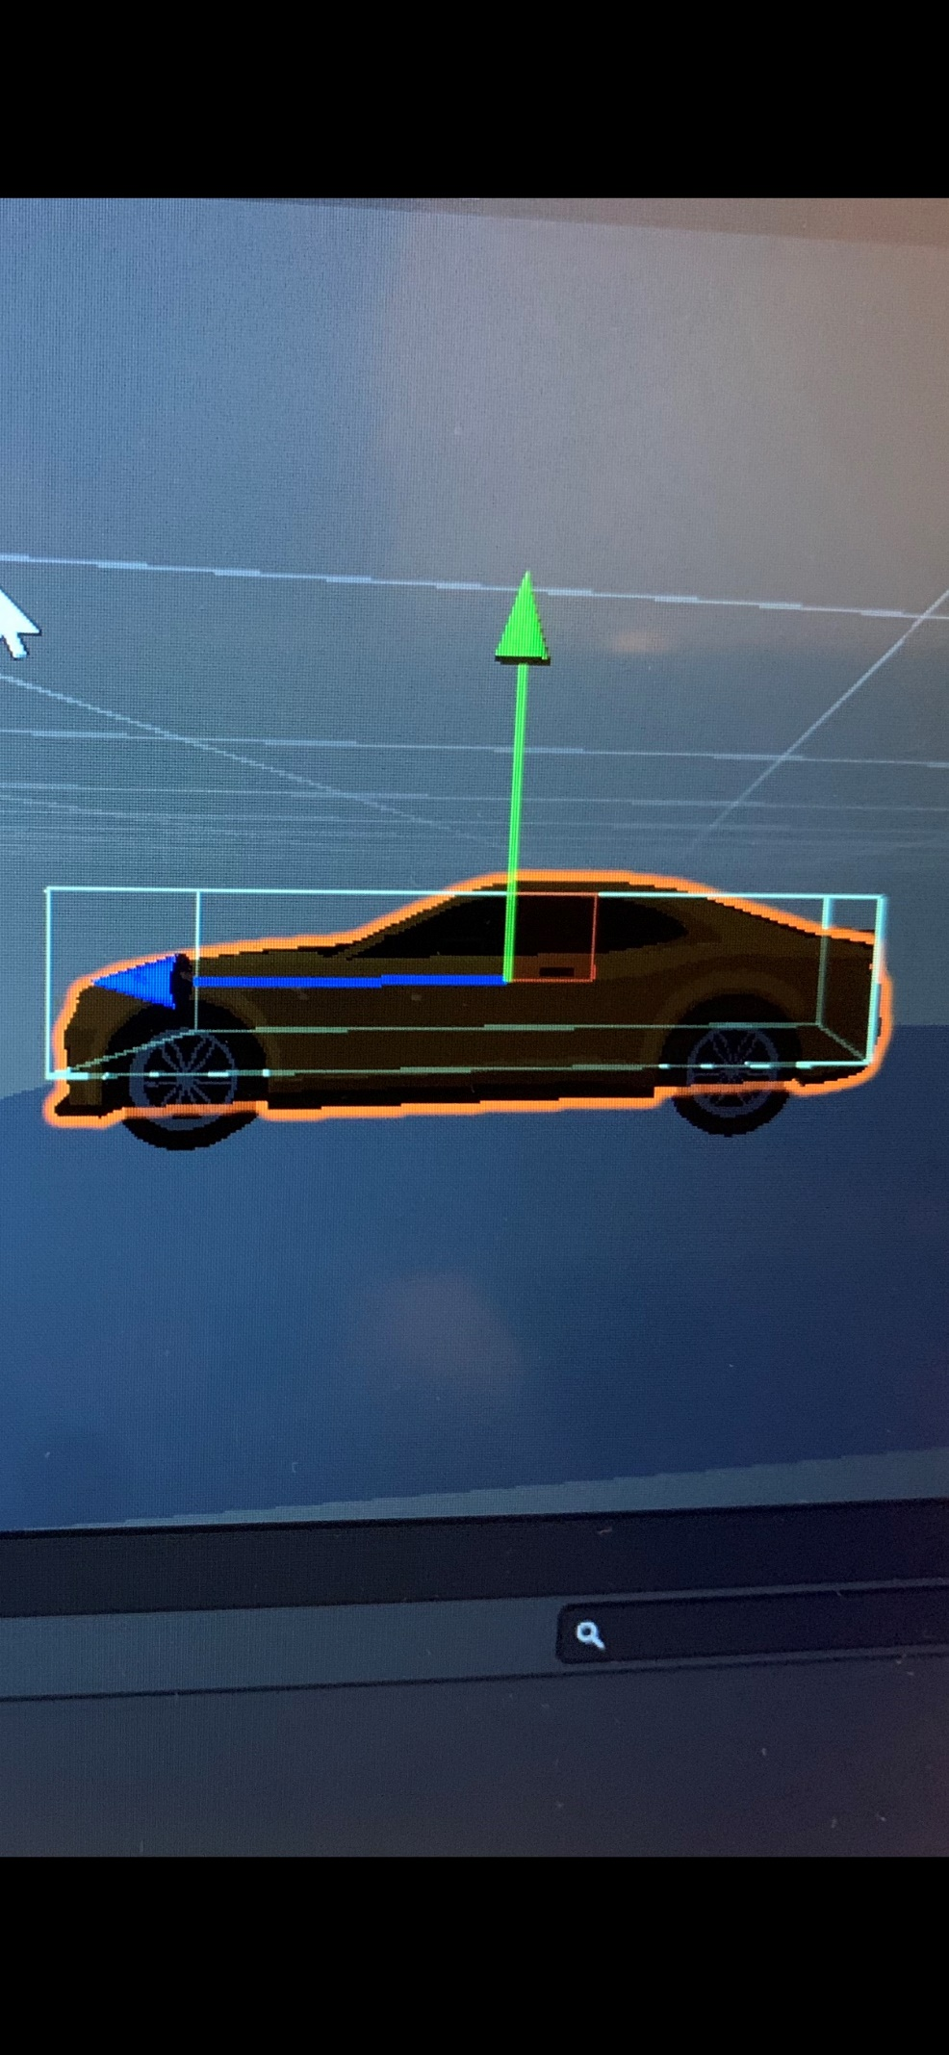
Press thing next to edit collider so you can put box on car
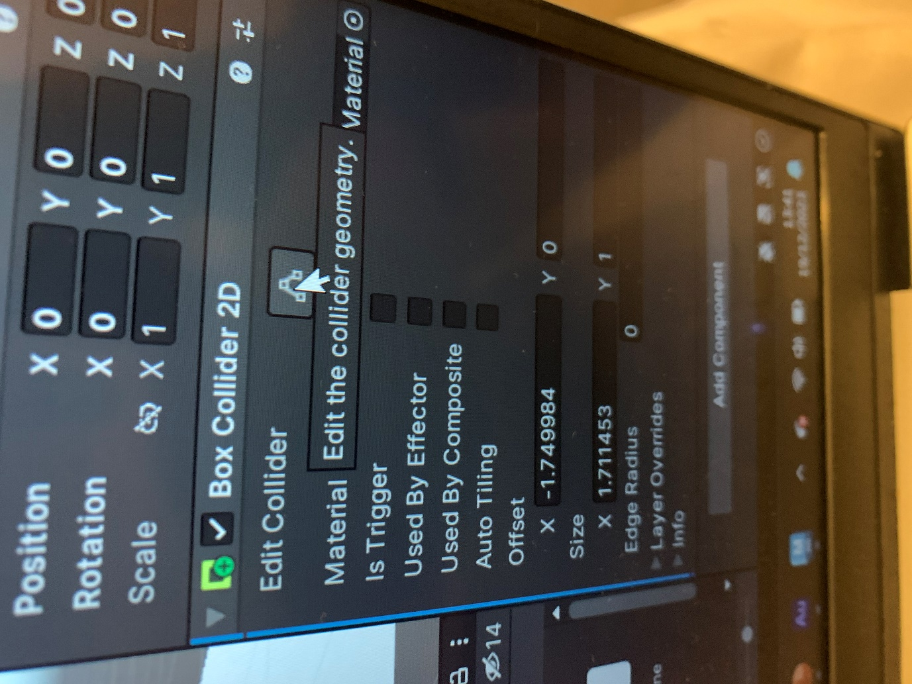

When done with collider add rigid object for physics 

